PATIENT NAME: Fawnn Alderman (F)
INSURANCE ID#: XOG911298121 DOB: 03/12/1970
ADDRESS: 11127 US HIGHWAY 14 WOODSTOCK, IL 60098
PHONE #: 815-354-7244
MEDICARE DESCRIPTION AND PROCEDURE CODES:
- POWER WHEELCHAIR GROUP STANDARD CAPTAIN CHAIR K0827 #1;
- BATTERY E2363 #2

VISION SUPER K0827
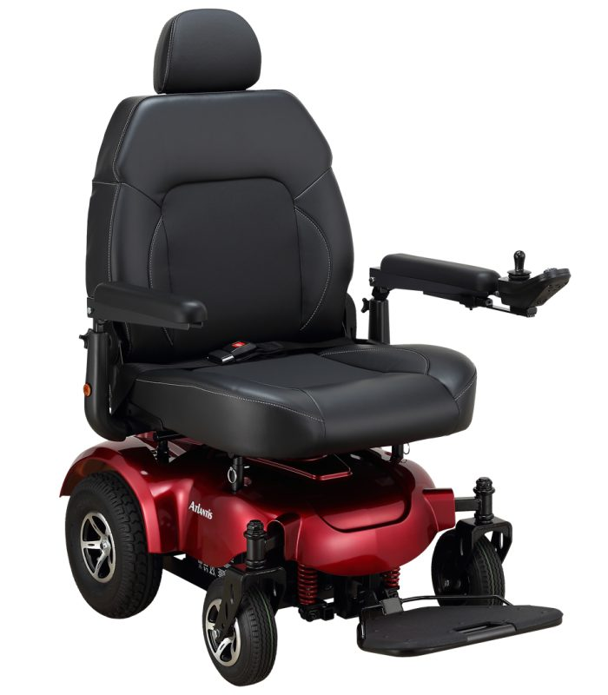
Features • Heavy-duty power wheelchair with a weight capacity of 600 lbs. • Four seat posts provide a stable and durable structure for the frame • Extra-wide seat and extra-high back provide great comfort for bariatric users • Super high power in-line motors help riders negotiate 10° uphill ramps with ease

Product# P710A
Weight Capacity 600 lbs.
Drivetrain RWD
Seat Type Captain
Seat Width 24.5”
Seat Depth 20”
Backrest Height 21.25”
Seat-to-Floor Height 22” - 23”
Overall Length 33”
Overall Width 32”
Overall Height 41.5”
Turning Radius 31.5”
Ground Clearance 2.75”
Total Weight 304 lbs.
Wt of Heaviest Pc. 167 lbs.
Max Speed 5 mph
Range Per Charge up to 32 mi.
Motor DC 24V / 300W
Controller Dynamic LiNX
Battery Size (2 required) 75Ah, M24 AGM
Charger 6A off-board
Gradient 10°
Front Wheels 9” pneumatic
Drive Wheels 12” pneumatic
Rear Wheels 3” anti-tippers
HCPCS Codes K0826 / K0827

**Patient Agreement:** I, ___________________________________ (Patient Name), acknowledge that I have reviewed the power wheelchair depicted in the accompanying picture. I understand its features and specifications and agree that this wheelchair meets my mobility needs as assessed by my healthcare provider. I consent to accept and use this specific power wheelchair as part of my mobility solution.

Patient’s Signature:__________________________________________________________ Date:_____________
Signature if other than patient:___________________________________Relationship:____________________
Name if other than patient:______________________________________________________________________
Reason patient is unable to sign:__________________________________________________________________
Evaluator’s Signature:_____________________________________________________ Date:________________
Evaluator’s Name (printed):_____________________________________________________________________

